To enable third party cookies on CHROME, please do the following:
Select the tools menu (three vertical dots on the top right corner of the page) and navigate to the settings page:
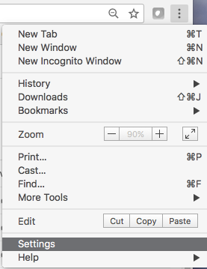

Scroll to the bottom of the page and expand the ‘Advanced section’:
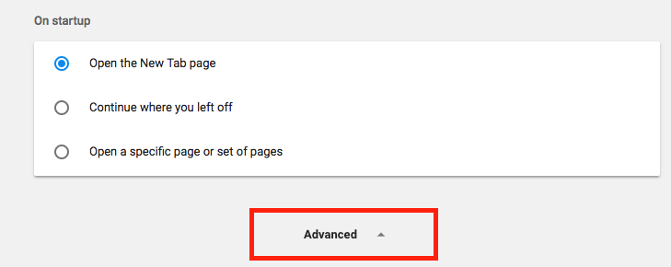

Within this section you will want to select the ‘Content Settings’:
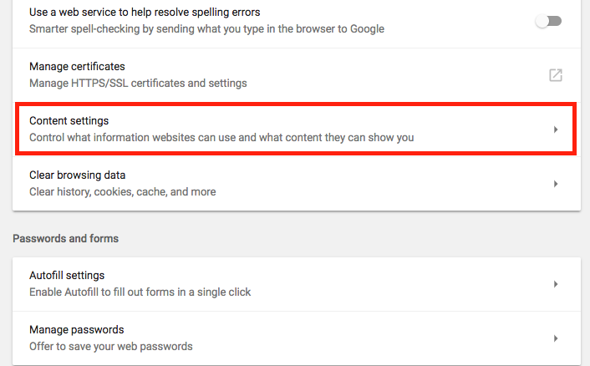

Then select ‘Cookies’:
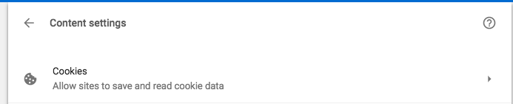

From this page you will be able to enable or disable third party cookies in your browser.

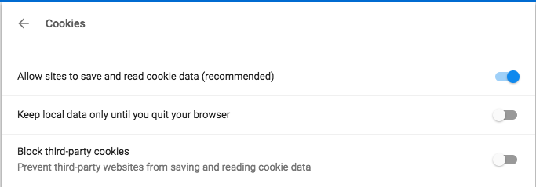

Please ensure that ‘Block Third-party cookies’ is greyed out- indicating that this feature is turned off.

